Before next lecture, talk with few potential users and at least one should be within your expected target group. Fill out the assignments below for your next lecture.
Assignment 1: Make a mind map of potential tests
We’ve worked with this during the “Lecture 4 - Prototype & user test”. Please add your answers here or insert a picture of the one you made on paper with all the possible user tests you could think of for your idea.

Pain points:

Assignment 2: Which user test is the most crucial to move on with the idea?
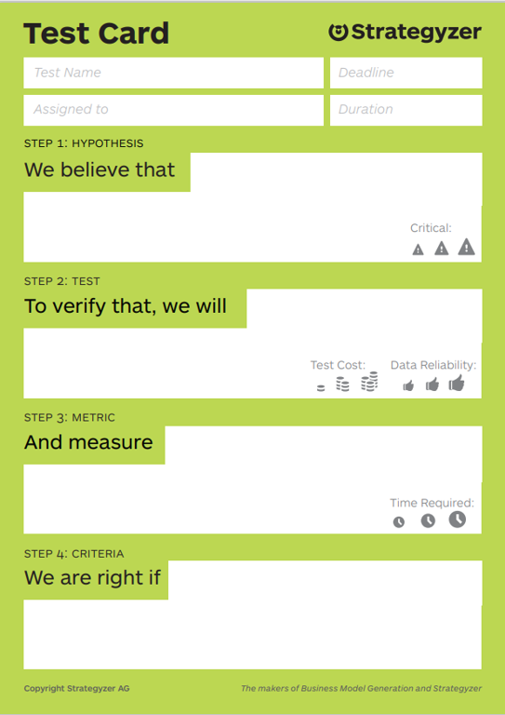
We’ve worked with this during the “Lecture 4 - Prototype & user test”. Please fill out the test card below or take a picture of the one you filled out in the workshop:
Assignment 3: Detail Planning of your user test
We’ve worked with this during the “Lecture 4 - Prototype & user test”. Please fill out the user test planning sheet below or take a picture of the one you filled out in the workshop:
What do you want to test?

Which type of user test?

Why?

How do you reach your target customer?

User tests should be done with test persons as close as possible to your target customer.
How many do you want to test with? Talk with several potential users and at least one should be within your target customer group
Number of tests: _____________

Where & when?
When will you perform the test?

… and where? (try to put yourself into the user’s perspective and find a place that’s suits the user)

How do you approach your test person?
- Do you need a medium to get in touch with your target customer?
- What is your starting line when approaching your target customer?
- How are you dressed?

How do you perform the user test?

Important tips:
- Ask open-ended questions like: What do you think… What is your expected…
- Make it clear for the test persons that they cannot do or say anything wrong.
- Remember to video tape or have one person dedicated to take notes (ask for permission to film)
- Let them know, that you’re here to learn from them and not to sell something.
- Listen and observe 80% of the time and ask questions 20% of the time.

Practicalities:

What do you need to prepare?

Who does what? Clear the roles beforehand: instructor, time keeper, notes, camera man, etc.

Which things do you need to support your test or visualization of your idea/concept?
Mock-ups? Other psychical objects that support you or the user?

Which outcome do you expect?

Assignment 4: Make a mock-up
During the “Lecture 4 - Prototype & user test” you made mock-ups (or visualizations) of your idea. Please insert a picture of your mock-up. If you have several mock-ups or iterations, put all pictures in. Remember prototyping is the conversation you have with your idea, so you might have learned something about your idea when making the first mock-up, that may lead you to do another one. Documentation of the entire process is important.

Assignment 5: After your user tests: What did you learn?
Now you have done user tests with several potential users with at least 1 within the target group. So what did you learn about your idea? Or the target group? Please fill out the learning card below or take a picture of the paper you got in the workshop:
